Shape and arrangement of bacterial cells
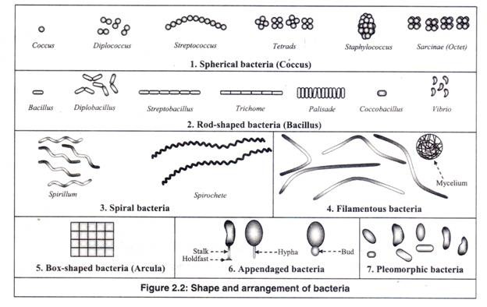1. Spherical Bacteria:
Bacteria, which are spherical or ovoid in shape, are called ‘coccus’ (plural: cocci) (Figure 2.2). Based on the arrangement of the cells they are of the following types.
(a) Coccus:
The spherical bacteria cells, called cocci, are present as single individuals.
(b) Diplococcus:
The cocci are arranged in pairs.
(c) Streptococcus:
The cocci are arranged in chains, as the cells divide in one plane.
(d) Tetrads:
The cocci are arranged in packets of four cells, as the cells divide in two plains.
(e) Staphylococcus:
The cocci are arranged in grape-like clusters formed by irregular cell divisions in three plains.
(f) Sarcinae (Octet):
The cocci are arranged in a cuboidal manner, as the cells are formed by regular cell divisions in three planes.
2. Rod-shaped Bacteria:
The cylindrical or rod-shaped bacteria are called ‘bacillus’ (plural: bacilli).
They are of three shapes as follows:
(a) Bacillus:
They are rod-shaped bacteria. Based on arrangement they are of the following types.
(i) Bacillus:
The rod-shaped bacteria cells, called bacilli, are present as single individuals.
(ii) Diplobacillus:
The bacilli are arranged in pairs.
(iii) Streptobacillus:
The bacilli are arranged in chains, as the cells divide in one plane.
(iv) Trichomes:
The bacilli are arranged in chains with larger area of end-to-end contact between the cells.
(v) Palisades:
The bacilli bend at the points of division following the cell divisions, resulting in a palisade arrangement resembling a picket fence and angular patterns that look like Chinese letters.
(b) Coccobacillus:
These are so short and stumpy that they appear ovoid. They look like coccus and bacillus.
(c) Vibrios:
They are comma-shaped bacteria with less than one complete turn or twist in the cell.
3. Spiral Bacteria:
Unlike the vibrios, which have less than one complete turn or twist in the cell, the spiral bacteria are rod-shaped bacteria, which have more than one twist in the cell. They usually occur singly.
They are of two types as follows:
(a) Spirillum:
They have rigid spiral structure. Spirillum with many turns can superficially resemble spirochetes. They do not have outer sheath and endoflagella, but have typical bacterial flagella.
(b) Spirochetes:
They are flexible and can twist and contort their shape. They have outer sheath and endoflagella, but lack typical bacterial flagella.
4. Filamentous Bacteria:
They are very long thin filament-shaped bacteria. Some of them form branching filaments resulting in a network of filaments called ‘mycelium’.
5. Box-shaped or Square-shaped Bacteria (Arcula):
They are flat, box-shaped bacteria with perfectly straight edges and sharp 90° angles at the corners. Smaller cells are usually perfectly squares (2X2µ), while larger cells are rectangular; about twice as long as they are wide (4X2µ).
Each bacterium is a thin flexible sheet with smooth surface. After cell divisions, the cells remain attached to each other, producing large sheets of squares. It was first discovered in 1980 in natural salt ponds.
6. Appendaged Bacteria:
They possess extension of their cells, as long tubes in the form of stalk or hypha, or as buds.
7. Pleomorphic Bacteria:
These bacteria do not have any characteristic shape unlike all others described above. They can change their shape. In pure cultures, they can be observed to have different shapes.

